Networking Task 1

Part A: Network Information
System details:
Hostname: Gitu
IPv4 Address. . . . . . . . . . . : 192.168.133.1
MAC Address. . . . . . . . . . :00:0A:95:9D:67:16
Default Gateway . . . . . . . . . : 192.168.0.1
Connection-specific DNS Suffix . : 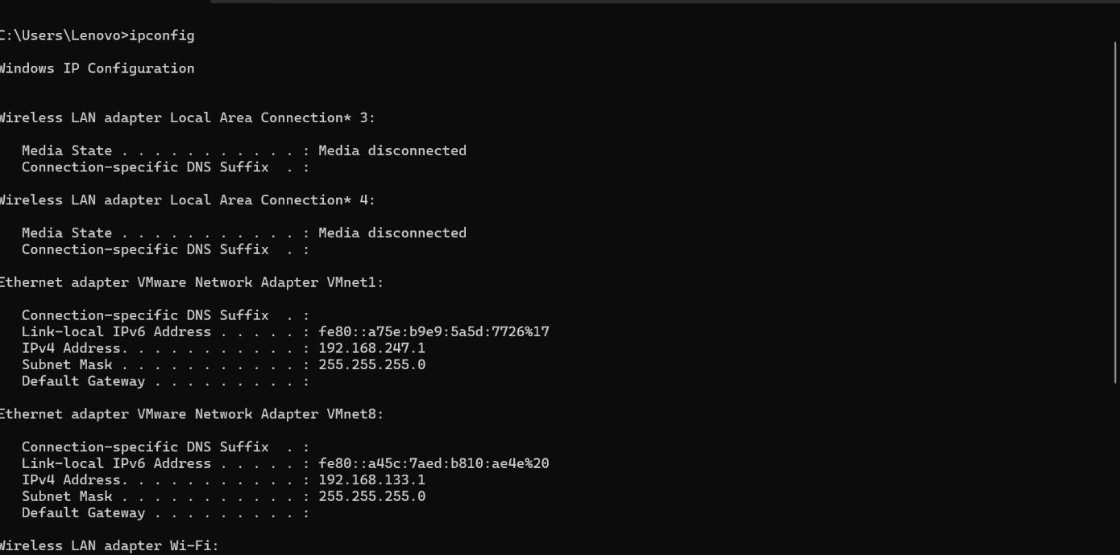
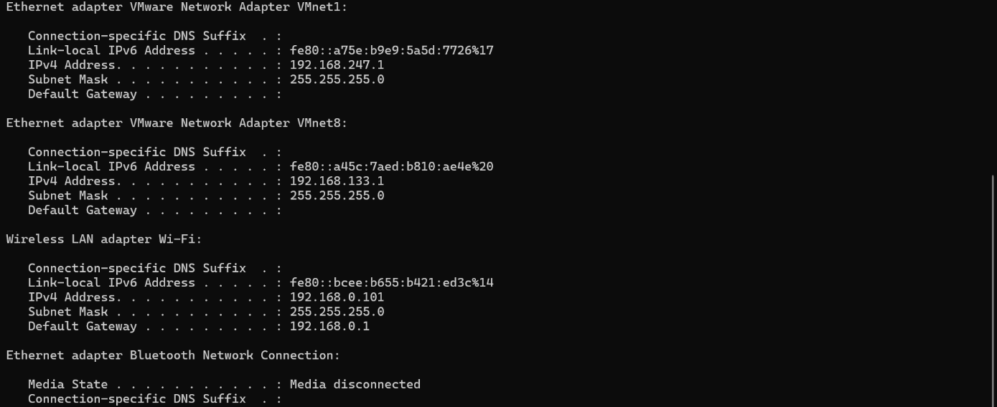

Part B: Basic Networking Concepts
1.What is an IP Address?
An IP Address is a unique number given to every device on a network. It works like a home address for your computer or phone, helping the internet know who you are and where to send information. There are two main versions: IPv4 (older, shorter numbers) and IPv6 (newer, longer numbers). It is essential for communication between devices on the internet.
2.What is an mac Address?
A MAC Address (Media Access Control Address) is a unique hardware number given to a device’s network card. It is like the permanent ID card of your computer or phone, fixed by the manufacturer. Unlike an IP Address which can change, a MAC Address never changes. It helps in identifying devices inside a local network.
3.What is a Default Gateway?
A Default Gateway is the device (usually a router) that connects your local network to the outside world, like the internet. It acts as the exit door for your computer, sending data to other networks when the destination is not inside your local network. Without a default gateway, your device can only talk to devices in the same local network. It is essential for internet access and communication between networks.
4.What is DNS?
A DNS (Domain Name System) is like the phonebook of the internet. It translates domain names (like google.com) into IP addresses that computers use to find websites. This makes it easier for people to use names instead of remembering long numbers. Without DNS, we would have to type IP addresses to open websites.
5.Difference between Public IP and Private IP?
- Public IP:
  - Given by your Internet Service Provider (ISP).
  - Used to identify your device on the internet.
  - Example: When you visit google.com, the website sees your public IP.
- Private IP:
  - Used inside your home, school, or office network.
  - Helps devices like computers, printers, and phones talk to each other locally.
  - Example: Your laptop may have 192.168.1.5 inside the Wi-Fi network.

Part C:Create a basic network diagram Hand Drawn Diagram:
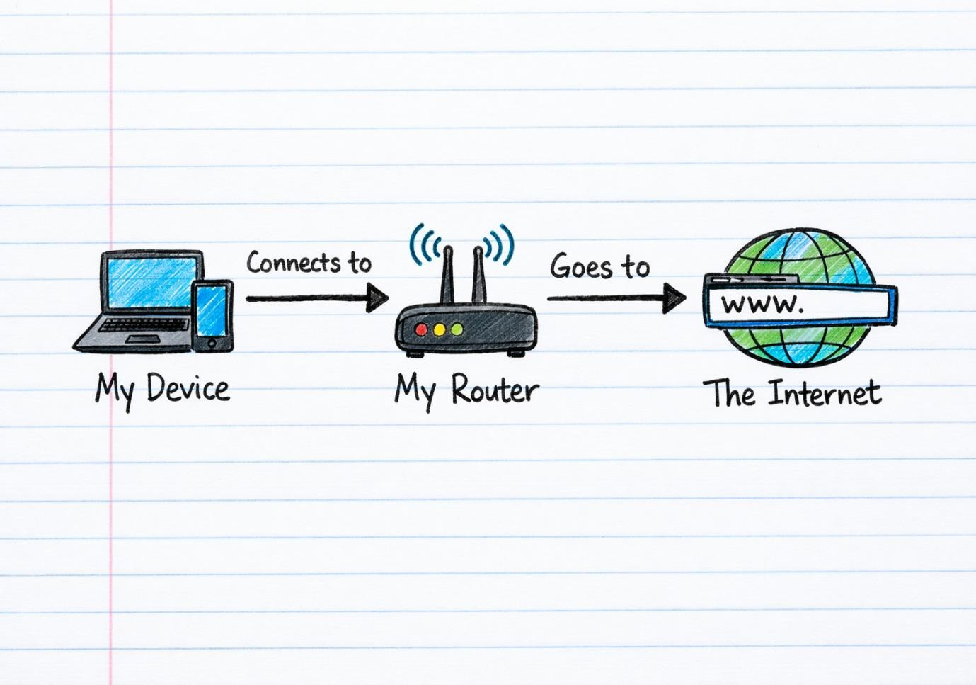

Part D: Network Connectivity Test
Windows Users
1.ipconfig
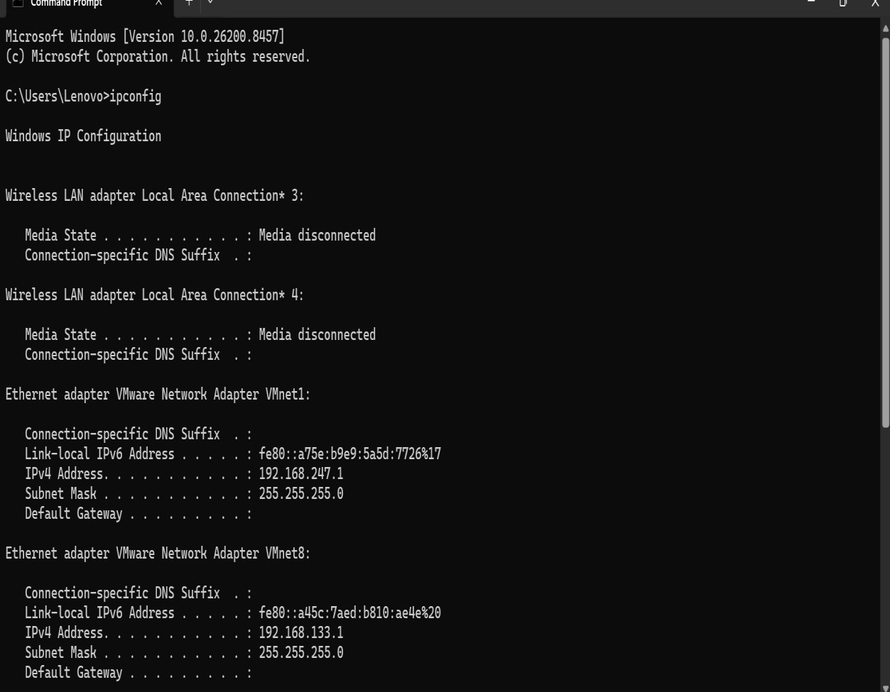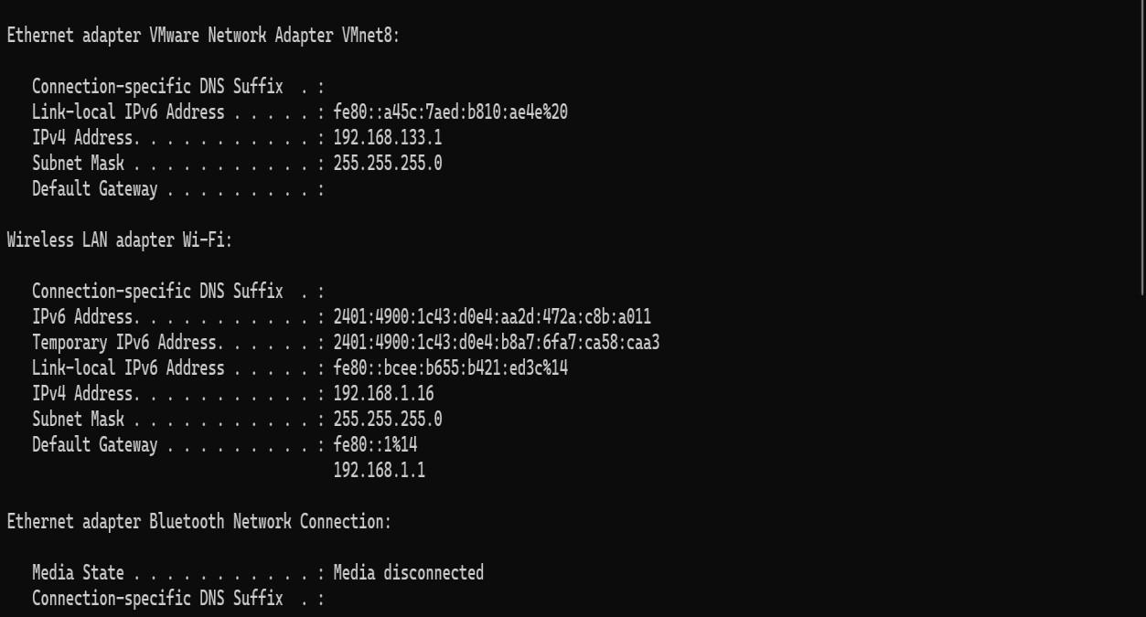
2.Ping google.com

3.tracert google.com
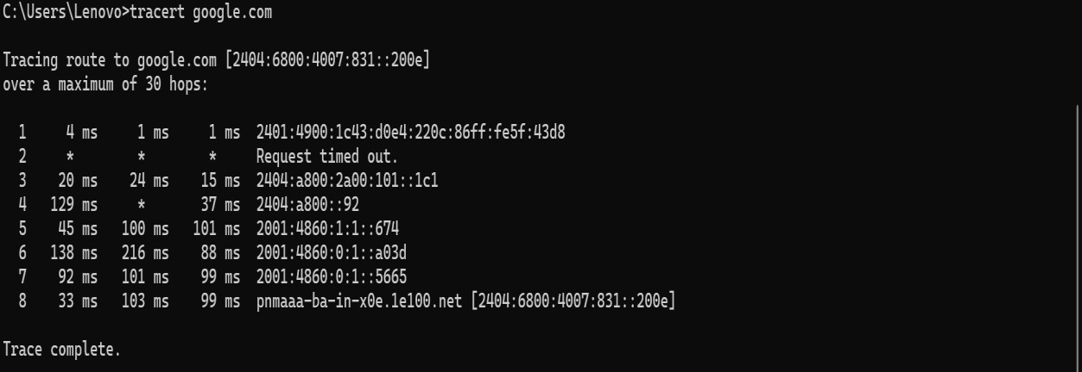
1.Was the ping successful?
Yes, the ping was successful if the device received replies from the destination. It means the connection between your computer and the target server is working.
2.How many hops were shown?
The number of hops shows how many routers or network devices your data passed through to reach the destination. Each hop represents one step in the journey across the network.
3.What is the purpose of traceroute?
Traceroute is used to find the Path data takes from your computer to a website or server. It helps identify where delays or problems occur in the network.

